Chapter 15, Problem 21.

Obtain the Laplace transform of the periodic waveform in Fig. 15.33.

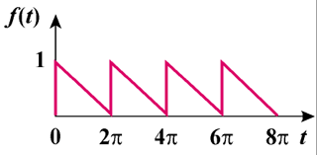

Figure 15.33
For Prob. 15.21.

